using System;

namespace ConsoleApp38
{
class Program
{
static void Main(string[] args)
{
int sumofodd = 0;
for (int i = 0; i < 50; i++)
{
if (i % 2==0)
{
Console.WriteLine("{0} is Even", i);
}
else
{
Console.WriteLine("{0} is Odd", i);
sumofodd += i;
}
}
Console.WriteLine("{0} is a sum of Odd no", sumofodd);
}
}
}

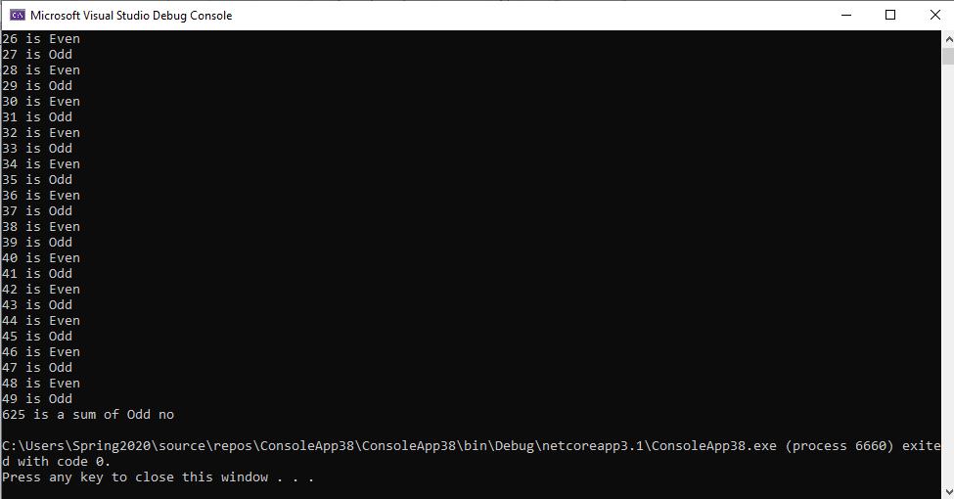

using System;

namespace ConsoleApp38
{
class Program
{
static void Main(string[] args)
{

for (int i = 97; i < 123; i++)
{
Console.Write("{0},", (Char)i);
}
}
}
}
